Software Requirements Specification
for
SKENA
Version 1.0 approved
Prepared by
1. Vitto Farin Kris (22091397096)
2. Rendareista N.R (22091397108)
3. M.Zidane Rizky (22091397111)
D4 MANAJEMEN INFORMATIKA
FAKULTAS VOKASI
UNIVERSITAS NEGERI SURABAYA
10 September 2023
Table of Contents
Table of Contents ii
Revision History ii
1. Introduction 1
1.1 Purpose 1
1.2 Document Conventions 1
1.3 Intended Audience and Reading Suggestions 1
1.4 Product Scope 1
1.5 References 1
2. Overall Description 2
2.1 Product Perspective 2
2.2 Product Functions 2
2.3 User Classes and Characteristics 2
2.4 Operating Environment 2
2.5 Design and Implementation Constraints 2
2.6 User Documentation 2
2.7 Assumptions and Dependencies 3
3. External Interface Requirements 3
3.1 User Interfaces 3
3.2 Hardware Interfaces 3
3.3 Software Interfaces 3
3.4 Communications Interfaces 3
4. System Features 4
4.1 System Feature 1 4
4.2 System Feature 2 (and so on) 4
5. Other Nonfunctional Requirements 4
5.1 Performance Requirements 4
5.2 Safety Requirements 5
5.3 Security Requirements 5
5.4 Software Quality Attributes 5
5.5 Business Rules 5
6. Other Requirements 5
Appendix A: Glossary 5
Appendix B: Analysis Models 5
Appendix C: To Be Determined List 6

Revision History
Name | Date | Reason For Changes | Version

Introduction

Purpose
<Identify the product whose software requirements are specified in this document, including the revision or release number. Describe the scope of the product that is covered by this SRS, particularly if this SRS describes only part of the system or a single subsystem.>

Document Conventions
<Describe any standards or typographical conventions that were followed when writing this SRS, such as fonts or highlighting that have special significance. For example, state whether priorities for higher-level requirements are assumed to be inherited by detailed requirements, or whether every requirement statement is to have its own priority.>

Intended Audience and Reading Suggestions
<Describe the different types of reader that the document is intended for, such as developers, project managers, marketing staff, users, testers, and documentation writers. Describe what the rest of this SRS contains and how it is organized. Suggest a sequence for reading the document, beginning with the overview sections and proceeding through the sections that are most pertinent to each reader type.>

Product Scope
<Provide a short description of the software being specified and its purpose, including relevant benefits, objectives, and goals. Relate the software to corporate goals or business strategies. If a separate vision and scope document is available, refer to it rather than duplicating its contents here.>

References
<List any other documents or Web addresses to which this SRS refers. These may include user interface style guides, contracts, standards, system requirements specifications, use case documents, or a vision and scope document. Provide enough information so that the reader could access a copy of each reference, including title, author, version number, date, and source or location.>

Overall Description

Product Perspective
Website ini bernama SKENA. Skena merupakan website yang memiliki peran sebagai jasa pembuatan dan penjualan desain. Website Skena memberikan banyak peluang untuk orang-orang terutama mahasiswa DKV yang memiliki keahlian dalam membuat desain, baik desain baju, logo, poster, bahkan desain apapun untuk menjualkan desainnya. Website Skena berfokuskan kepada mahasiswa DKV yang mana dapat membantu mahasiswa DKV memiliki nilai jual dan peluang usaha yang sesuai dengan setiap desain yang dibuatnya. Tak hanya mahasiswa DKV, setiap orang yang memiliki minat dan bakat dalam mendesain produk, dapat menggunakan website Skena.

Product Functions
- Membuat desain secara gratis dengan berbagai contoh / referensi yang menarik
- Mengenalkan desain produk kepada khalayak umum
- Memberikan nilai jual kepada desain produk yang sesuai
- Membantu mahasiswa DKV dan pecinta desain mempromosikan desainnya

User Classes and Characteristics
Kategori Pengguna | Tugas | Hak Akses ke aplikasi | Kemampuan yang harus dimiliki
Admin | Melihat Laporan | Memasukkan, Edit, Menghapus Data | Memantau laporan hasil penjualan
Admin | Edit akun penjual | Memasukkan, Edit, Menghapus Data | Mengedit akun penjual, menghapus yang tidak sesuai dengan perjanjian kerjasama mitra
Admin | Edit produk | Memasukkan, Edit, Menghapus Data produk | Memantau produk agar tidak terjadi plagiarisme
Admin | Mengirim notifikasi ke penjual, pembeli | Mengatur, mengedit, memberikan notifikasi terkait update website, produk, atau mitra | Memantau perubahan secara real time
Penjual | Melihat Laporan | Memasukkan, Edit, Menghapus Data | Memantau, mengedit laporan hasil penjualan
Penjual | Edit Produk | Memasukkan, Edit, Menghapus Data produk | Membuat desain produk
Penjual | Melihat pesanan yang masuk | Memasukkan, Edit, Menghapus Data pesanan | Memantau, memberikan konfirmasi terkait pemesanan produk klien
Penjual | Mengirim pesan ke pembeli | Mengirim pesan terkait desain yang dipesan oleh klien | Memberikan pesan secara fast kepada klien
Pembeli | Melihat produk | Melihat produk | Melihat produk desain yang ada
Pembeli | Memilih produk | Memilih produk untuk disimpan, disukai, dimasukkan keranjang | Memilih desain yang sesuai dengan keinginan
Pembeli | Melakukan pembayaran | Melakukan pembayaran / checkout | Membayar sesuai harga desain menggunakan apl yang tersedia
Pembeli | Melihat status pesanan | Melihat status pesanan apakah desain sudah terkonfirmasi terjual | Melihat status pesanan dengan seksama
Pembeli | Memberikan feedback | Mengedit, membuat feedback terkait desain, terkait kecepatan penjual menjual | Memberikan feedback yang sesuai

Operating Environment
<Describe the environment in which the software will operate, including the hardware platform, operating system and versions, and any other software components or applications with which it must peacefully coexist.>

Design and Implementation Constraints
<Describe any items or issues that will limit the options available to the developers. These might include: corporate or regulatory policies; hardware limitations (timing requirements, memory requirements); interfaces to other applications; specific technologies, tools, and databases to be used; parallel operations; language requirements; communications protocols; security considerations; design conventions or programming standards (for example, if the customer’s organization will be responsible for maintaining the delivered software).>

User Documentation
<List the user documentation components (such as user manuals, on-line help, and tutorials) that will be delivered along with the software. Identify any known user documentation delivery formats or standards.>

Assumptions and Dependencies
<List any assumed factors (as opposed to known facts) that could affect the requirements stated in the SRS. These could include third-party or commercial components that you plan to use, issues around the development or operating environment, or constraints. The project could be affected if these assumptions are incorrect, are not shared, or change. Also identify any dependencies the project has on external factors, such as software components that you intend to reuse from another project, unless they are already documented elsewhere (for example, in the vision and scope document or the project plan).>

External Interface Requirements

User Interfaces
<Describe the logical characteristics of each interface between the software product and the users. This may include sample screen images, any GUI standards or product family style guides that are to be followed, screen layout constraints, standard buttons and functions (e.g., help) that will appear on every screen, keyboard shortcuts, error message display standards, and so on. Define the software components for which a user interface is needed. Details of the user interface design should be documented in a separate user interface specification.>

Hardware Interfaces
<Describe the logical and physical characteristics of each interface between the software product and the hardware components of the system. This may include the supported device types, the nature of the data and control interactions between the software and the hardware, and communication protocols to be used.>

Software Interfaces
<Describe the connections between this product and other specific software components (name and version), including databases, operating systems, tools, libraries, and integrated commercial components. Identify the data items or messages coming into the system and going out and describe the purpose of each. Describe the services needed and the nature of communications. Refer to documents that describe detailed application programming interface protocols. Identify data that will be shared across software components. If the data sharing mechanism must be implemented in a specific way (for example, use of a global data area in a multitasking operating system), specify this as an implementation constraint.>

Communications Interfaces
<Describe the requirements associated with any communications functions required by this product, including e-mail, web browser, network server communications protocols, electronic forms, and so on. Define any pertinent message formatting. Identify any communication standards that will be used, such as FTP or HTTP. Specify any communication security or encryption issues, data transfer rates, and synchronization mechanisms.>

System Features
Fitur Sistem yang ada di website kami:

Homepage / Halaman Utama
4.1.1 Description and Priority
Halaman utama menampilkan halaman utama skena itu sendiri dengan menu yang tersedia yakni menu home, logo, desain, sign up, dan tombol menekan desain.
4.1.2 Stimulus/Response Sequences
Stimulus 1: Admin, penjual ataupun pembeli membuka website
Respon 1: Sistem menampilkan halaman utama skena
Stimulus 2: Penjual menekan button design
Respon 2: Sistem akan membukakan halaman untuk mengedit desain
Stimulus 3: Admin, penjual ataupun pembeli menekan halaman logo
Respon 3: Sistem akan menampikan halaman berbagai desain logo (yang mana logo ini menjadi sauatu ikon desain paling utama skena)
Stimulus 4: Admin, penjual ataupun pembeli menekan halaman desain
Respon 4: Sistem menampilkan halaman dengan berbagai desain yang ada di skena
Stimulus 5: Penjual dan pembeli sign up
Respon 5: Sistem menampilkan halaman sign up hanya untuk penjual dan pembeli

4.1.3 Functional Requirements
Halaman Utama | Admin, penjual, pembeli | Membuka website
Halaman Utama | sistem | Membuka website
Halaman Utama | penjual | Membuat desain
Halaman Utama | sistem | Mengarahkan ke halaman membuat desain
Halaman Utama | Admin, penjual, pembeli | Menekan menu logo
Halaman Utama | sistem | Mengarahkan ke halaman yang penuh desain/referensi logo
Halaman Utama | penjual, pembeli | Sign Up
Halaman Utama | sistem | Memberikan halaman sign up.

System Feature 2 (and so on)

Other Nonfunctional Requirements

Performance Requirements
<If there are performance requirements for the product under various circumstances, state them here and explain their rationale, to help the developers understand the intent and make suitable design choices. Specify the timing relationships for real time systems. Make such requirements as specific as possible. You may need to state performance requirements for individual functional requirements or features.>

Safety Requirements
<Specify those requirements that are concerned with possible loss, damage, or harm that could result from the use of the product. Define any safeguards or actions that must be taken, as well as actions that must be prevented. Refer to any external policies or regulations that state safety issues that affect the product’s design or use. Define any safety certifications that must be satisfied.>

Security Requirements
<Specify any requirements regarding security or privacy issues surrounding use of the product or protection of the data used or created by the product. Define any user identity authentication requirements. Refer to any external policies or regulations containing security issues that affect the product. Define any security or privacy certifications that must be satisfied.>

Software Quality Attributes
<Specify any additional quality characteristics for the product that will be important to either the customers or the developers. Some to consider are: adaptability, availability, correctness, flexibility, interoperability, maintainability, portability, reliability, reusability, robustness, testability, and usability. Write these to be specific, quantitative, and verifiable when possible. At the least, clarify the relative preferences for various attributes, such as ease of use over ease of learning.>

Business Rules
<List any operating principles about the product, such as which individuals or roles can perform which functions under specific circumstances. These are not functional requirements in themselves, but they may imply certain functional requirements to enforce the rules.>

Other Requirements
<Define any other requirements not covered elsewhere in the SRS. This might include database requirements, internationalization requirements, legal requirements, reuse objectives for the project, and so on. Add any new sections that are pertinent to the project.>
Appendix A: Glossary
<Define all the terms necessary to properly interpret the SRS, including acronyms and abbreviations. You may wish to build a separate glossary that spans multiple projects or the entire organization, and just include terms specific to a single project in each SRS.>
Appendix B: Analysis Models
Use Case Diagram
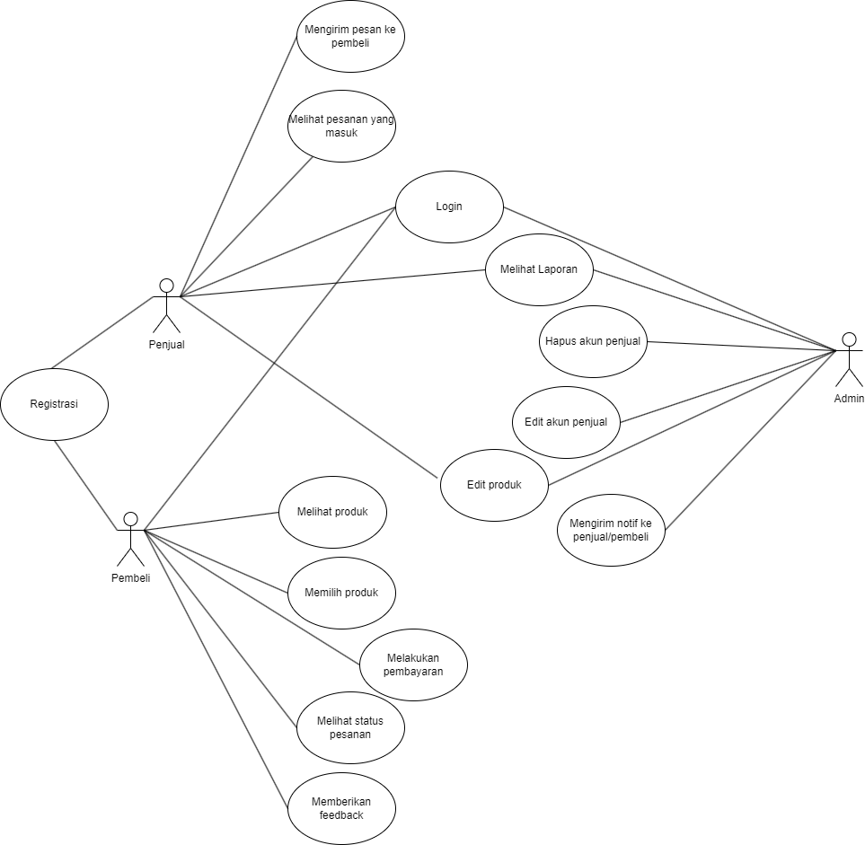

Flowchart
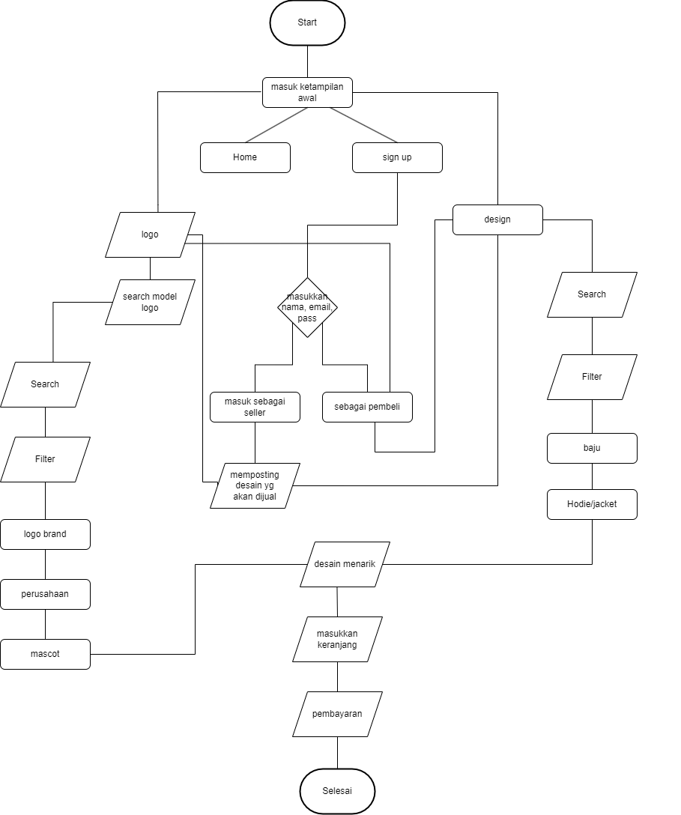

Desain Website

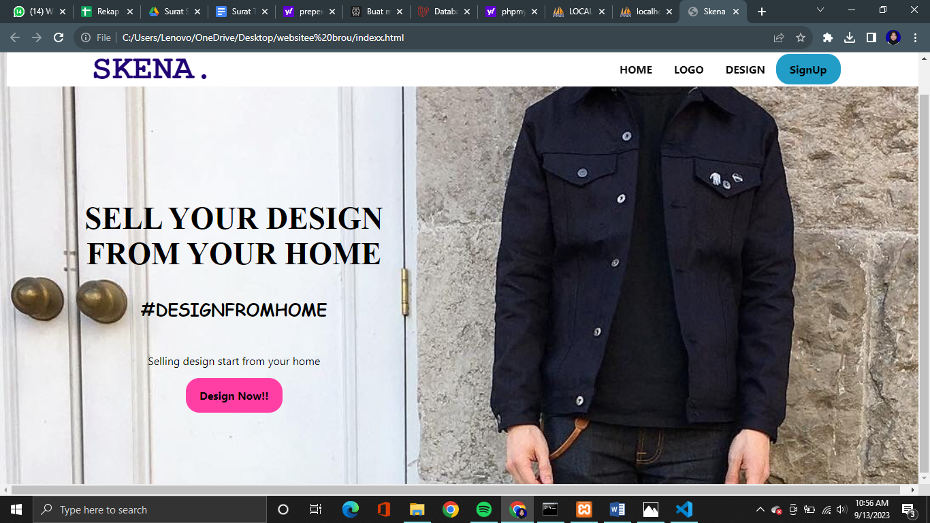

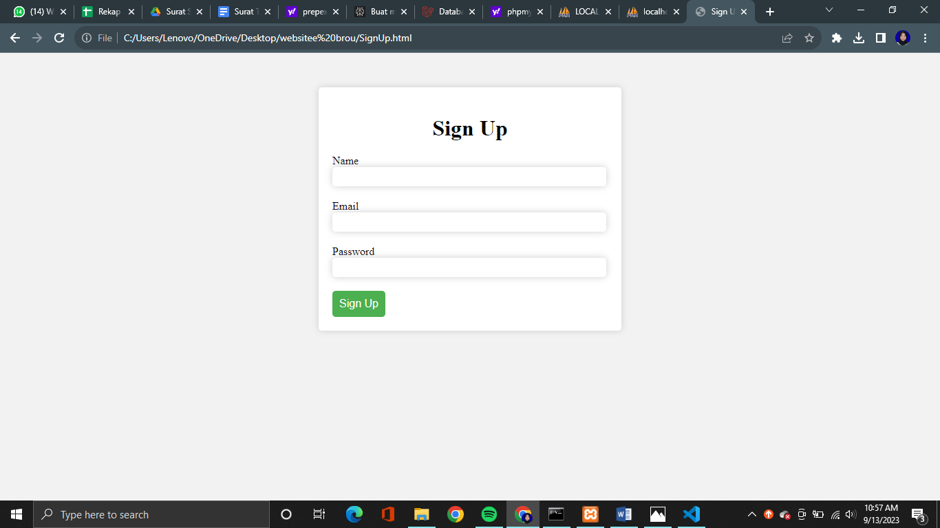

Appendix C: To Be Determined List
<Collect a numbered list of the TBD (to be determined) references that remain in the SRS so they can be tracked to closure.>

